**New insights into the mechanism of action of Trofinetide: An exploratory in silico study.**

**Luis Felipe Hernández Ayala, Gabriel Eduardo López Guzmán, Annia Galano**

**Abstract**

**Keywords:**

**Introduction**

Rett syndrome (RTT) is a rare and complex genetic neurodevelopmental disorder that primarily affects girls, with an estimated prevalence of 1 in 10,000 to 15,000 live births [1]. It is characterized by a period of apparently normal development, followed by a progressive regression of motor, social, and communication skills. Critical symptoms of the disease include the loss of voluntary use of the hands and the appearance of repetitive movements, gait disturbances, severe cognitive impairment, respiratory irregularities, seizures, dysautonomia, and metabolic alterations such as dyslipidemia, insulin resistance, or mitochondrial dysfunction [2–4]. These manifestations reflect a multisystemic affectation that impacts both the central nervous system as well as the endocrine and bioenergetic systems. The course of the disease leads to a progressive deterioration that compromises the quality of life of patients, who require permanent medical attention and specialized care [5]. Although life expectancy can extend into adulthood, it varies depending on the phenotype, severity of symptoms, and quality of medical management [6].

The main cause of RTT is the presence of mutations in the MECP2 gene, located on the X chromosome, which encodes the methyl CpG-binding protein 2, a transcription regulator essential for neuronal maturation and synaptic plasticity [7]. There are also atypical variants of the syndrome that occur less frequently and are due to mutations in the CDKL5 or FOXG1 genes [8]. The disease usually appears between 6 and 18 months of age and causes lifelong disability, with no curative treatment currently available. Since in its early stages, symptoms can be confused with disorders such as autism, early diagnosis represents a major clinical challenge.

Until recently, the therapeutic approach to RTT was limited to disease control through the use of drugs and physical, occupational, and speech therapies. These actions are primarily aimed at mitigating the most disabling clinical manifestations, such as motor disorders, epileptic seizures, respiratory, digestive, and autonomic disorders, as well as behavioral problems. In this context, the use of anticonvulsants, anxiolytics, serotonergic modulators, beta-blockers, as well as interdisciplinary functional support strategies, is common [1].

In 2023, the FDA approved the drug Trofinetide, marking a milestone by becoming the first targeted therapy for this disease [9]. Trofinetide is an analogous of Glypromate (Glycine-Proline-Glutamic Acid or simply GPE) peptide derived from the N-terminus of insulin-like growth factor 1 (IGF-1) and was designed to cross the blood-brain barrier and partially restore impaired neuronal functions in patients with MECP2 deficiency. Clinical trial results have shown that its administration produces significant improvements in some symptoms of the disease, such as non-verbal communication, social interaction, breathing pattern, sleep, and reduction of stereotyped movements [10]. However, its use is frequently associated with side effects, particularly diarrhea, decreased appetite, vomiting, and weight loss, which may require dose adjustment or discontinuation of treatment in severe cases [11].

Although no information has been reported that allows a precise elucidation of the mechanism of action of Trofinetide, available preclinical and clinical studies suggest that it modulates different convergent processes in RTT. It is known that the administration of the drug promotes the reduction of neuroinflammation, the activation of microglia, the formation of new neuronal connections and the restoration of dendritic structure [12,13]. These effects could be related to the signaling pathways regulated by IGF-1, although a specific molecular target that explains its action has not been identified [10].

The present study aims to explore, using structure-based computational tools, the potential interactions of Trofinetide with a set of proteins relevant to the pathophysiology of Rett syndrome, to generate mechanistic hypotheses about its multitarget mode of action. A systematic approach is proposed that analyzes the coupling of Trofinetide with proteins classified into four functional groups: i) Neurotransmission, ii) Cellular metabolism, iii) Neuroinflammation and oxidative stress (OS) and iv) Drug metabolism.

Each system will be analyzed by comparison with reference ligands (endogenous substrates or recognized modulators) as functional comparators. Affinity, steric complementarity, and binding site similarity metrics will be used to assess the plausibility of a relevant direct interaction, as well as to validate the specificity of the computational protocol. This approach will allow for the validation of the appropriateness of the docking protocol, the identification of targets with potential functional relevance, and the formulation of new hypotheses regarding the molecular mechanism of action of Trofinetide, in order to guide future experimental validations and computational drug design for RTT disease.

**Methodology**

*Target election*

A combination of database searching, target prediction, and literature review was used to select potential therapeutic receptors and estimate the pharmacological efficiency of the designed compounds against RTT.

DrugBank and ChEMBL databases [25,26] were used to search for information about the Trofinetide mechanism of action and its experimental reported or computationally predicted molecular targets .

For the prediction of potential molecular targets of Trofinetide and GPE, three complementary platforms were used: SwissTargetPrediction (STP) [27], PharmMapper (PM) [28] and PASS Online (PO) [29], each with different approaches based on structural chemistry or biological activity. The selection of relevant targets was based on two main criteria: high probability or predicted affinity (Probability ≥ 0.1 in STP, NormFit > 0.8 in PM, or Pa > 0.7 in PO) and relevance in the context of Rett syndrome. This approach allows to prioritize highest biological plausibility targets.

In addition, information on phase 3 clinical trials of drugs targeting Rett syndrome was obtained through the US National Institutes of Health's ClinicalTrials.gov platform [30]. The goal is to identify therapeutic targets modulated by investigation agents with known mechanisms of action.

And at the same time, a review of the recent literature was carried out to complement the receptors with a therapeutic potential with promising potential for the condition [1-19,20-26,27,31-79]. Finally, a refinement was carried out, choosing only the receptors whose structure is reported in the protein data bank [80], to carry out molecular docking studies.

*Protonation States*

The deprotonation pathway of Trofinetide and GPE were estimated using the Marvin Suite platform [81] as a reference. Then, the pKa values ​​were refined through a parametric fitting protocol based on density functional theory (DFT) electronic structure calculations [82]. The calculations were performed with Gaussian 09 [83] with a M05/6-311+G(d,p) level of theory. The accurate determination of pKa is essential in the context of drug design, since it regulates the fraction of neutral species present at physiological pH, which have a higher probability of crossing biological barriers by passive diffusion. This methodology has been previously validated, showing a satisfactory correlation with experimental values ​​reported in the literature [84].

*Molecular Docking*

The structures of the crystallized proteins were obtained from protein data bank [85], the data of the proteins code and co-crystallized ligands are in the Table SX2 in supporting information (SI). Misplaced loop regions in the proteins were fixed using Modeller [86]. Water molecules, ions and non-relevant species of the protein were removed using Autodock Tools [87]. The protonation state of the side chains was considered at physiological pH= 7.4. Aspartic and glutamic acid were considered as deprotonated species. Arginine, lysine and histidine were considered with its protonated lateral chains. GROMOS96 [88] force field in the Deep View/Swiss PDB Viewer 4.1.0 software [89] were applied for protein energy minimization. Atomic charges of all ligands were estimated as single points, using the NBO protocol with the DFT theory at M05-2X/6-311+G(d,p) level. The charges of the protein were added as Kollman type [90]. All the docking simulations were carried out with AutoDock Vina 1.2.0 [91]. A gradient optimization algorithm was performed on the active or allosteric sites in the proteins (see Table SX1 in SI). For the copper-zinc superoxide dismutase (SOD) a blind docking was done since a no ligand co-crystallized structure was found in the database, then, a new docking simulation was performed in the site of major affinity. Docking scores (ΔGB) were reported for the best pose and weighted (ΔGBW) according to the molar fractions of most relevant species at pH = 7.4.

$${∆G}_{B}^{W}=\sum_{i=1}^{n}{X_{(i)}{∆G}_{B(i)}}$$

Validation of the docking protocol was carried out using redocking simulations. These simulations were performed with co-crystallized ligands that, in most cases, act as reference drugs (RD). The obtained RMSD values are in the range of 0.62 to 2.99 Å. For analysis purposes, the simulations of endogenous substrates (ES) with the corresponding receptors were also performed. To compare A polygenic index (PS) was designed. Two variants were calculated: one relative to reference modulators ($P_{S}^{RM}$) and another relative to endogenous substrates ($P_{S}^{ES}$). Mathematically, these indices have the following form:

$$P_{S}^{RM}= log \frac{∆{G^{W}}_{B_{p}}}{{∆G}_{B_{RM}}} P_{S}^{ES}= log \frac{∆{G^{W}}_{B_{p}}}{{∆G}_{B_{ES}}}$$

where $∆{G^{W}}_{B_{p}}$ is the weighted docking score for Trofinetide or GPE and, ${∆G}_{B_{RM}}$ and ${∆G}_{B_{ES}}$ are the scores for the corresponding reference modulator and endogenous substrate respectively.

The protein-ligand conformations with the major were drawn and analyzed with Discovery Studio software [92]. Then, the interaction similarity score *SSI* [93] was estimated to taken into account the conformation profile in relation to the endogenous substrate and modulator reference conformations. This *SSI* is defined as follows:

$$S_{SI}=\frac{N_{MR}+N_{MI}}{{2N}_{RR}}$$

where *NMR* is the number of residues present in both the compound and the reference ligand, *NMI* is the number of exact matches in the type of interaction (hydrogen bonding, π forces, etc.) between those residues, and *NRR* is the total number of residues involved in the interaction between the enzyme and the reference ligand.

**Results**

*Target selection*

The differences in the molecular interaction profiles between Trofinetide and GPE, observed in the results predicted by target fishing, may be partially explained by their structural differences. Although both share the GPE (Gly-Pro-Glu) core, trofinetide features a structural modification with an additional methyl group at the glutamic terminus, which improves its metabolic stability and permeability in the CNS (ref). Additionally, this modification could allow greater versatility in molecular recognition, facilitating interaction with targets such as PPARγ, MAO-B, or PTP1B, which were predicted by the platforms exclusively for trofinetide and not for GPE.

Trofinetide showed greater affinity for experimentally supported targets in RTT models, supported by the cross-reference between the targets predicted by target fishing (Table S1) and the curated data of relevant targets in RTT (Table 1). Notably, Trofinetide presented matches with GSK3β, PTP1B, MAO-B, σ1R, and COMT, all with preclinical or clinical evidence in RTT, whereas GPE only shared AMPA and P2X7, with only indirect support for the pathophysiology of the disease. This greater concordance suggests that the structural modification of Trofinetide not only improves its pharmacokinetic profile but potentially optimizes its ability to modulate functional targets in RTT, which could contribute to its observed clinical efficacy.

In the databases reviewed and in the FDA clinical information, Trofinetide was identified as a substrate for UGT2B15 and the hepatic transporter OATP1B1, which are involved in processes related to drug metabolism and excretion, respectively. However, no interactions with cytochrome P450 enzymes were observed, suggesting a distinct elimination pathway from many neuroactive drugs. Although these proteins are not directly involved in the pathophysiology of RTT, they will be incorporated as validation controls in the molecular docking protocol: UGT2B15 and OATP1B1 as positive controls, as they have documented interactions, and CYP450 as a negative control, as it lacks them.

Finally, to define the most relevant molecular targets for docking studies, we conducted a literature review based on experimental and clinical data associated with Rett syndrome (RTT). This process included a systematic review of clinical trials, mechanistic studies, pharmacological interventions, and receptor alterations reported in RTT models. The list was refined through cross-validation with databases and expanded by incorporating targets predicted by computational methods. As a result, a total of 28 molecular targets were selected, covering neurotransmission, synaptic plasticity, metabolic regulation, oxidative stress, inflammation, and drug metabolism. In this context, Table 1 summarizes the proteins selected for molecular docking with trofinetide, highlighting their acronym and their reported or proposed relevance in the pathophysiology of RTT, based on experimental models or clinical evidence.

|  |  |  |  |
| --- | --- | --- | --- |
| **Table 1.** Molecular targets ans their relevance in RTT | | | |
| Protein | | Acronym | Relevance in RTT |
| Neurotransmission | N-Methyl-D-Aspartate receptor | NMDA | Its modulation improves respiratory patterns and short-term plasticity. In vivo studies with memantine, ketamine, and dextromethorphan [14,15]. |
| GABA transporter 1 | GAT1 | Its dysregulation has been observed in RTT models, affecting the excitatory-inhibitory balance [16,17]. |
| Metabotropic GABA receptor type B | GABAB | Altered expression has been associated with motor and behavioral dysfunction in RTT. Preclinical evidence in KO mice [14,16]. |
| Ionotropic GABA receptor type A | GABAA | Its imbalance with glutamatergic receptors contributes to the clinical phenotype of RTT. Targeted in GABA-based therapies [15,17]. |
| Muscarinic acetylcholine receptor M1 | CHRM1 | Cholinergic alterations have been identified in RTT models [16]. |
| Dopamine receptor D2 | D2Dr | The D2 agonist sarizotan was evaluated in clinical trials for respiratory symptoms in RTT [15]. |
| Serotonin receptor 2A | 5HT2A | Serotonergic dysregulation has been observed in RTT [15]. |
| Adenosine receptor A2A | A2AR | Activation exerts neuroprotective effects. Functional studies in neurological models suggest involvement in RTT [16]. |
| Na⁺/K⁺/Cl⁻  cotransporter 1 | NKCC1 | GABA signaling analyses in RTT models show that altered function contributes to excitatory/inhibitory imbalance [16]. |
| Serotonin transporter | hSERT | Selective serotonin reuptake ihibitors increases MeCP2 expression and have shown partial clinical benefit in RTT [14]. |
| Acetylcholinesterase | AChE | Cholinergic studies in RTT show functionally relevant alterations [16]. |
| Monoamine oxidase B | MAOB | Monoaminergic metabolism abnormalities have been described in RTT patients and models [18]. |
| Catechol-O-methyl transferase | COMT | May modulate dopamine and norepinephrine levels [16]. |
| Ionotropic AMPA-type glutamate receptor | AMPA | Glutamatergic neurotransmission is dysregulated in RTT models [16,17] . |
| Sigma 1 receptor | σ1R | Involved in neuroprotection. Preclinical evidence in RTT models. Blarcamesine an agonist is now in clinical trials against RTT [17,19]. |
| Metabolism | Glycogen synthase kinase 3 beta | GSK3β | Implicated in neuroinflammation; proposed as a therapeutic target in preclinical RTT models [16]. |
| Peroxisome proliferator-activated receptor gamma | PPARγ | PPARγ agonists have shown neuroprotective effects in RTT models [20]. |
| Proline dehydrogenase | ProdH | Overexpressed in Mecp2-KO brains. Contributes to redox imbalance and mitochondrial damage in RTT [17]. |
| 3-hydroxy-3-methylglutaryl-CoA reductase | HMGCR | Modulates cholesterol synthesis; inhibition improves motor symptoms and longevity in Mecp2 models [21]. |
| Protein tyrosine phosphatase 1B | PTP1B | Overexpressed in RTT patient brains and Mecp2-/y models. Inhibition restores PI3K–Akt signaling involved in cell survival [21]. |
| Oxidative stress and neuroinflamation | Xanthine oxidase | XO | Implicated in systemic oxidative stress observed in RTT patients and models [17]. |
| Superoxide dismutase | SOD | It is reduced brains and peripheral tissues of Mecp2 models, contributing to oxidative damage vulnerability [16]. |
| Cyclooxygenase 2 | COX‑2 | Participates in inflammatory processes; overexpressed in models with glial activation and oxidative damage [23]. |
| P2X purinoceptor 7 | P2X7 | Involved in microglial activation and neurotoxicity in RTT [24]. |
| Neuronal nitric oxide synthase | nNOS | Dysregulation may contribute to oxidative damage in Mecp2-/y brains [16]. |
| Drug metabolism | UDP glucuronosyltransferase 2B15 | UGT2B15 | Identified as the main metabolic pathway for Trofinetide in clinical and preclinical studies [13]. |
| Organic anion transporting polypeptide 1B1 | OATP1B1 | Hepatic transporter involved in Trofinetide uptake; systemic role confirmed in clinical drug–drug interaction studies [13]. |
| Cytochrome P450 enzymes | P450 | Trofinetide does not significantly interact with major CYP isoforms. Used as a methodological control [10,13]. |

*Acid-Base equilibria*

No experimental pKa values ​​reported for Trofinetide or GPE were found in the literature, so they were determined using validated computational estimates. In the Scheme 2 the deprotonation route for both compounds is found.

Acid-base speciation analysis showed that Trofinetide and GPE exhibit virtually identical deprotonation pathways, with the successive formation of five species. At physiological pH (pH = 7.4), both molecules exhibit a distribution dominated by anionic ( $X_{(H_{2}{X)}^{-}}$ = 0.71) and dianionic ( $X_{(H{X)}^{2-}}$ = 0.28) species, while neutral, cationic, and trianionic forms are virtually nonexistent under these conditions. This similarity suggests that the functional differences between the two compounds are not related to their acid–base profile, but to other structural and electronic factors.

**Scheme 2**. Deprotonation routes for Trofinetide and GPE respectively.

*Molecular docking*

Affinity values ​​weighted by the mole fraction of the predominant acid-base species at physiological pH allowed us to compare the interaction profile of Trofinetide and glypromate with a panel of 28 receptors selected for their potential relevance in Rett syndrome. Overall, Trofinetide showed higher affinities than GPE. Although individual differences are not markedly large, overall affinities slightly favor Trofinetide.

Comparing the values ​​of both peptides with the corresponding endogenous substrates or reference modulators included in the study revealed consistent patterns. Across multiple targets, the peptides showed higher affinity than the physiological substrates, suggesting a potential competitive modulatory capacity and consistent with the proposed multitarget activity of Trofinetide. However, the reference modulators exhibited, as expected, the highest affinities in most cases.

Regarding the validation targets used in the methodological protocol, P450, OATP1B1, and UGT2B15, the latter two have been identified as elimination pathways in clinical and preclinical studies and were therefore included as positive controls. Indeed, Trofinetide showed similar or even higher scores than the references (-8.42 and -8.08 kcal/mol, respectively), consistent with the reported pharmacokinetic data. In contrast, at P450, both peptides presented significantly lower affinities (-6.29 and -6.31 kcal/mol) than those of the endogenous substrate and the reference modulator, corroborating the absence of experimental interaction with this enzymatic system and thus validating its inclusion as a negative control.

|  |  |  |  |  |
| --- | --- | --- | --- | --- |
| **Table 2**. Weighted docking score (ΔGWB) of Trofinetide, Glipromate, endogenous substrates (ES), and reference modulators (MR) on selected RTT-related targets. | | | | |
| Receptor | ΔGWB(kcal/mol) | | | |
| Trofinetide | GPE | ES | MR |
| NMDAr | -6.12 | -5.80 | -5.02 | -6.10 |
| GAT1 | -7.64 | -7.09 | -4.1 | -8.06 |
| GABAB | -8.46 | -8.60 | -5.08 | -8.43 |
| GABAA | -6.53 | -6.69 | -3.33 | -8.61 |
| CHRM1 | -7.50 | -6.91 | -4.75 | -8.3 |
| D2Dr | -6.74 | -6.24 | -6.243 | -10.11 |
| 5HT2A | -7.24 | -6.76 | -6.84 | -11.68 |
| A2AR | -6.73 | -6.84 | -7.03 | -10.23 |
| NKCC1 | -7.23 | -6.96 | --- | -8.4 |
| hSERT(CS) | -7.13 | -6.82 | -6.79 | -8.89 |
| hSERT(AlS) | -6.38 | -6.11 | --- | -7.72 |
| AChE | -8.25 | -8.09 | -4.90 | -12.01 |
| MAOB | -4.68 | -6.46 | -6.00 | -10.00 |
| COMT | -5.21 | -5.36 | -5.40 | -7.60 |
| AMPA | -6.83 | -6.9 | -4.77 | -9.16 |
| σ1r | -7.92 | -7.75 | --- | -7.88 |
| GSK3β | -8.80 | -9.36 | --- | -7.81 |
| PPARγ | -6.11 | -6.01 | -7.05 | -8.11 |
| ProdH | 2.81 | 1.42 | -5.86 | -5.72 |
| HMG-CoA(AS) | -5.44 | -5.36 | -5.41 | -5.77 |
| HMG-CoA(A) | -6.27 | -6.25 | --- | -7.19 |
| HMG-CoA(B) | -6.31 | -6.26 | --- | -7.83 |
| PTP1B | -5.04 | -5.00 | --- | -6.37 |
| XO | -5.05 | -5.35 | -6.43 | -5.65 |
| CuZn-SOD | -6.78 | -7.35 | --- | -6.94 |
| COX2 | -6.58 | -6.90 | -7.66 | -8.80 |
| P2X7 | -8.95 | -8.92 | -8.55 | -7.49 |
| nNOS | -7.26 | -7.24 | -6.26 | -7.13 |
| P450 | -6.29 | -6.31 | -8.096 | -9.65 |
| OATP1B1 | -8.42 | -8.17 | -8.229 | -8.20 |
| UGT2B15 | -8.08 | -7.72 | -6.109 | -6.42 |

To more precisely compare the relative affinities of Trofinetide and GPE for endogenous substrates (ES) and reference modulators (RM), the polygenic score was estimated. A positive value indicates that the compound has a higher affinity than the reference substrate or modulator, while a negative value indicates the opposite.

The graph based on endogenous substrates (Figure 1, top) revealed that both trofinetide and GPE displayed higher affinities for several targets involved in neurotransmission, including GABAB, GABAA, GAT1, and CHRM1, among others. Overall, Trofinetide displayed slightly higher scores than GPE for this set of targets, suggesting a more favorable interaction profile. In contrast, GPE displayed a higher score only for MAO-B, which could reflect differential modulation of this signaling pathway. Notably, both compounds exhibited positive values ​​for P2X7, a receptor with experimental implications for microglial activation in models of Rett syndrome (ref). In contrast, the reference modulator-based graph (Figure 1, bottom) showed predominantly negative values, which was expected since these compounds were specifically designed to exhibit high affinity for their respective receptors. However, Trofinetide maintained a competitive relative affinity against several pathophysiologically relevant targets, such as GSK3β, nNOS, and P2X7, all of which are linked to neuroinflammation and oxidative stress processes in RTT. Once again, these findings reinforce the hypothesis of a possible multitarget modulatory effect of Trofinetide.

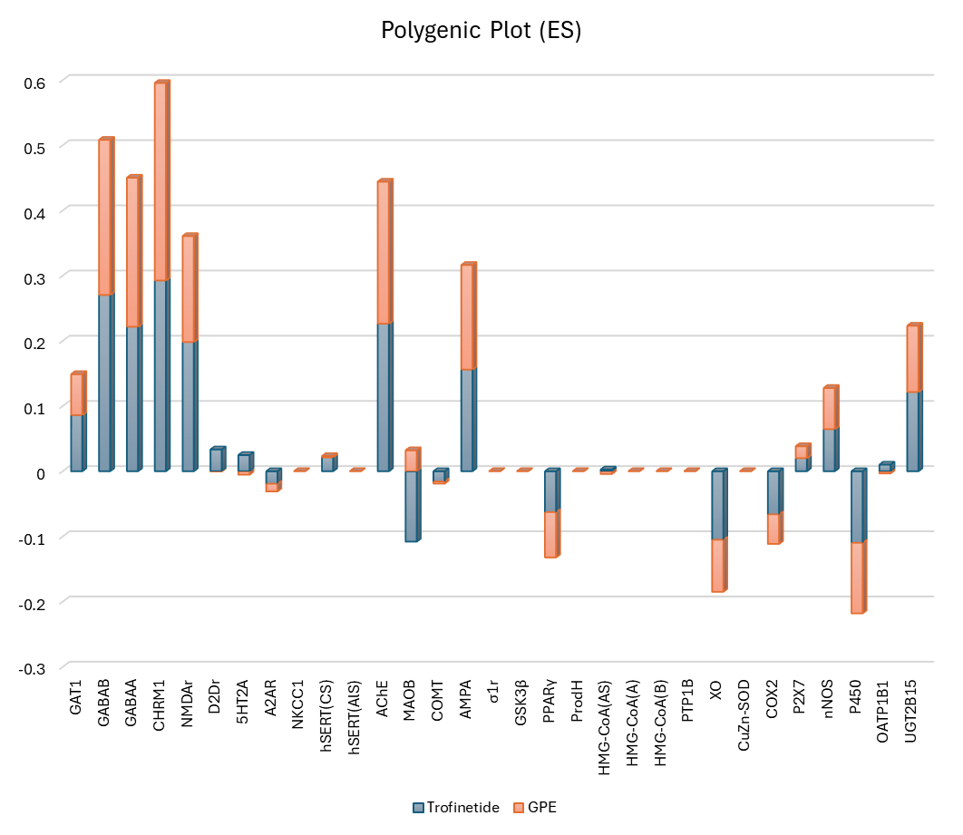

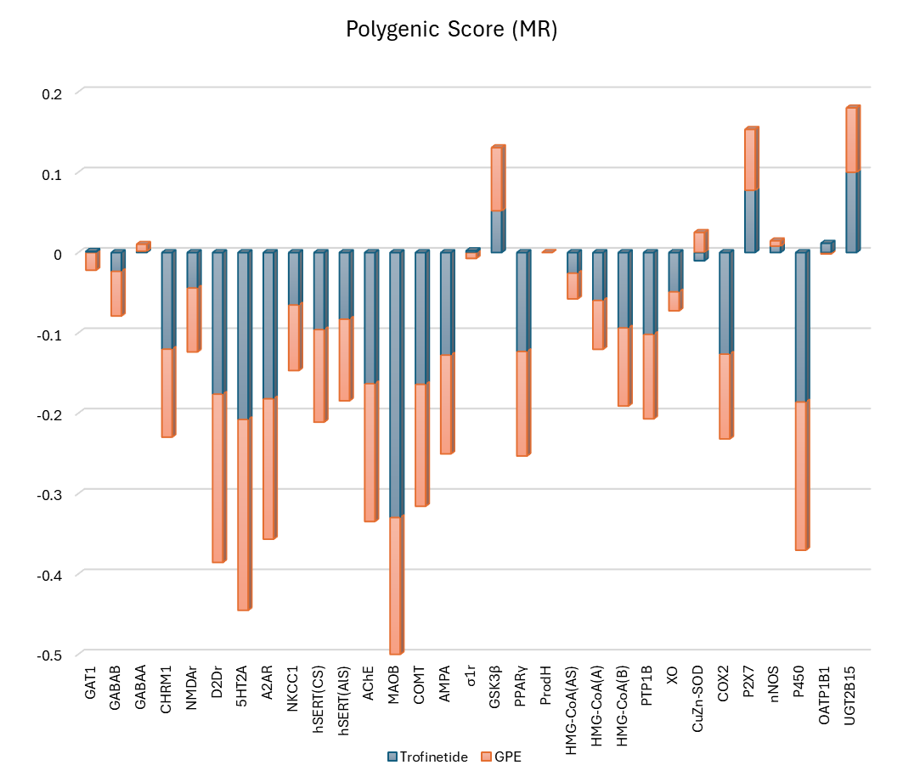

**Figure 1.** Trofinetide and GPE polygenic score plot relative to endogenous substrate (top) and reference modulator (bottom).

**Conclusions**

**Acknowledgements**

The work in Mexico was supported by Ciencias Básica y de Frontrera project SECIHTI No. CBF2023-2024-1141. We thank the Yoltla and Miztli Clusters for the computing resources. L.F.H.A thanks to Estancias Posdoctorales por México (2022) SECIHTI program for the postdoctoral grant.

**References**

1. Neul JL, et al. Rett syndrome: Revised diagnostic criteria and nomenclature. Ann Neurol. 2010;68(6):944–950. https://pubmed.ncbi.nlm.nih.gov/21154482/

2. Buchovecky CM, et al. The role of mitochondria in Rett syndrome. Dis Model Mech. 2013;6(1):17–25. https://www.ncbi.nlm.nih.gov/pmc/articles/PMC3537514/

3. Panighini A, et al. Dysregulation of lipid metabolism in Rett syndrome models. Neurobiol Dis. 2013; 50:140–149. <https://pubmed.ncbi.nlm.nih.gov/23022264/>

4. Motil KJ, et al. Gastrointestinal and nutritional problems occur frequently throughout life in girls and women with Rett syndrome. J Pediatr Gastroenterol Nutr. 2012;55(3):292–298. https://pubmed.ncbi.nlm.nih.gov/22357206/

5. Epstein A, et al. The impact of Rett syndrome on quality of life. J Child Neurol. 2021;36(7):557–563. https://pubmed.ncbi.nlm.nih.gov/33739127/

6. Tarquinio DC, et al. The changing face of survival in Rett syndrome and MECP2-related disorders. Pediatr Neurol. 2015;53(5):402–411. https://pubmed.ncbi.nlm.nih.gov/26315311/

7. Amir RE, et al. Rett syndrome is caused by mutations in X-linked MECP2, encoding methyl-CpG-binding protein 2. Nat Genet. 1999;23(2):185–188. https://pubmed.ncbi.nlm.nih.gov/10508514/

8. Neul JL, et al. Specific mutations in CDKL5 and FOXG1 cause atypical variants of Rett syndrome. J Neurodev Disord. 2014;6(1):25. https://www.ncbi.nlm.nih.gov/pmc/articles/PMC4101771/

9. FDA. FDA approves first treatment for Rett syndrome. https://www.fda.gov/drugs/news-events-human-drugs/fda-approves-first-treatment-rett-syndrome

10. Glaze DG et al. A phase 3 trial of Trofinetide in Rett syndrome. Nat Med. 2023;29:909–917. <https://www.nature.com/articles/s41591-023-02398-1>

11. Trofinetide (Daybue™) – Prescribing information, NDA 217026. <https://www.accessdata.fda.gov/drugsatfda_docs/label/2023/217026s000lbl.pdf>

12. Castro J et al. Functional recovery with recombinant human IGF-1 in a mouse model of Rett syndrome. Proc Natl Acad Sci U S A. 2014;111(27):9941–9946. https://www.pnas.org/doi/10.1073/pnas.1400113111

13. Trofinetide – DrugBank DB06045. https://go.drugbank.com/drugs/DB06045

14. Chapleau CA, et al. Recent Progress in Rett Syndrome and MeCP2 Dysfunction: Assessment of Potential Treatment Options. Future Neurol. 2013;8(1):69–88. [https://doi.org/10.2217/fnl.12.79](https://doi.org/10.2217/fnl.12.79%20)

15. Ehinger Y, et al. Rett syndrome from bench to bedside: recent advances. F1000Research. 2018;7:398. <https://doi.org/10.12688/f1000research.14039.1>

16. Ehrhart F, et al. Rett syndrome – biological pathways leading from MECP2 to disorder phenotypes. Orphanet J Rare Dis. 2016;11:158. <https://doi.org/10.1186/s13023-016-0521-1>

17. Filosa S, Pecorelli A, Lucchesi C, et al. Exploring the possible link between MeCP2 and oxidative stress in Rett syndrome. Free Radic Biol Med. 2015;88(Pt A):81–90. <https://doi.org/10.1016/j.freeradbiomed.2015.06.029>

18. R.C. Samaco, C. Mandel-Brehm, H. Chao, C.S. Ward, S.L. Fyffe-Maricich, J. Ren, K. Hyland, C. Thaller, S.M. Maricich, P. Humphreys, J.J. Greer, A. Percy, D.G. Glaze, H.Y. Zoghbi, & J.L. Neul, Loss of MeCP2 in aminergic neurons causes cell-autonomous defects in neurotransmitter synthesis and specific behavioral abnormalities, Proc. Natl. Acad. Sci. U.S.A. 106 (51) 21966-21971, https://doi.org/10.1073/pnas.0912257106 (2009).

19. ClinicalTrials.gov. A Study of Trofinetide for the Treatment of Girls With Rett Syndrome (LAVENDER). Identifier: NCT04304482. U.S. National Library of Medicine. Updated August 8, 2023. Available from: <https://clinicaltrials.gov/study/NCT04304482>

20. Mony L, et al. PPAR gamma agonists as neuroprotective agents: implications for Rett syndrome. Neuropharmacology. 2018;131:127–138.

[https://doi.org/10.1016/j.neuropharm.2017.12.018](https://doi.org/10.1016/j.neuropharm.2017.12.018 )

21. Buchovecky CM, et al. A suppressor screen in Mecp2 mutant mice implicates cholesterol metabolism in Rett syndrome. Nat Genet. 2013;45(9):1013–1020. <https://doi.org/10.1038/ng.2714>

22. Krishnan N, et al. Targeting the PTP1B–AMPK signaling axis improves energy metabolism and neurodegeneration in Rett syndrome. Nat Neurosci. 2015;18:1658–1670. https://doi.org/10.1038/nn.4144

23. Kamal, D.A.M., Abidin, S.Z., Saudi, W.S.W. et al. Roles of Prostaglandins and Cyclooxygenases in Autism Spectrum Disorder: A Comprehensive Review. Curr Behav Neurosci Rep 12, 2 (2025). https://doi.org/10.1007/s40473-024-00294-7

24. Garré, J.M., Silva, H.M., Lafaille, J.J. et al. P2X7 receptor inhibition ameliorates dendritic spine pathology and social behavioral deficits in Rett syndrome mice. Nat Commun 11, 1784 (2020). <https://doi.org/10.1038/s41467-020-15590-5>

25.

26

27.

28.

29.

30.

31. Petriti U, Dudman DC, Scosyrev E, Lopez-Leon S. Global prevalence of Rett syndrome: systematic review and meta-analysis. Syst Rev. 2023 Jan 16;12(1):5. doi: 10.1186/s13643-023-02169-6

32. Wenk GL. Rett syndrome: neurobiological changes underlying specific symptoms. Prog Neurobiol. 1997 Mar;51(4):383-91. doi: 10.1016/s0301-0082(96)00059-7

33. Leonard H, Cobb S, Downs J. Clinical and biological progress over 50 years in Rett syndrome. Nat Rev Neurol. 2017 Jan;13(1):37-51. doi: 10.1038/nrneurol.2016.186.

34. Wulffaert J, Van Berckelaer-Onnes IA, Scholte EM. Autistic disorder symptoms in Rett syndrome. Autism. 2009 Nov;13(6):567-81. doi: 10.1177/1362361309338184.

35. Lee JY, Leonard H, Piek JP, Downs J. Early development and regression in Rett syndrome. Clin Genet. 2013 Dec;84(6):572-6. doi: 10.1111/cge.12110.

36. Nomura Y, Segawa M, Hasegawa M. Rett syndrome--clinical studies and pathophysiological consideration. Brain Dev. 1984;6(5):475-86. doi: 10.1016/s0387-7604(84)80030-3.

37. Schmidt A, Zhang H, Cardoso MC. MeCP2 and Chromatin Compartmentalization. Cells. 2020 Apr 3;9(4):878. doi: 10.3390/cells9040878.

38. Na ES, Nelson ED, Kavalali ET, Monteggia LM. The impact of MeCP2 loss- or gain-of-function on synaptic plasticity. Neuropsychopharmacology. 2013 Jan;38(1):212-9. doi: 10.1038/npp.2012.116.

39. Qiu Z, Sylwestrak EL, Lieberman DN, Zhang Y, Liu XY, Ghosh A. The Rett syndrome protein MeCP2 regulates synaptic scaling. J Neurosci. 2012 Jan 18;32(3):989-94. doi: 10.1523/JNEUROSCI.0175-11.2012.

40. Guy J, Cheval H, Selfridge J, Bird A. The role of MeCP2 in the brain. Annu Rev Cell Dev Biol. 2011;27:631-52. doi: 10.1146/annurev-cellbio-092910-154121

41. De Felice C, Signorini C, Leoncini S, Pecorelli A, Durand T, Valacchi G, Ciccoli L, Hayek J. The role of oxidative stress in Rett syndrome: an overview. Ann N Y Acad Sci. 2012 Jul;1259:121-35

42. Shulyakova N, Andreazza AC, Mills LR, Eubanks JH. Mitochondrial Dysfunction in the Pathogenesis of Rett Syndrome: Implications for Mitochondria-Targeted Therapies. Front Cell Neurosci. 2017 Mar 14;11:58. doi: 10.3389/fncel.2017.00058.

43. Müller M. Disturbed redox homeostasis and oxidative stress: Potential players in the developmental regression in Rett syndrome. Neurosci Biobehav Rev. 2019 Mar;98:154-163. doi: 10.1016/j.neubiorev.2018.12.009.

44. Gonçalez JL, Shen J, Li W. Molecular Mechanisms of Rett Syndrome: Emphasizing the Roles of Monoamine, Immunity, and Mitochondrial Dysfunction. Cells. 2024 Dec 17;13(24):2077. doi: 10.3390/cells13242077.

45. De Felice C, Ciccoli L, Leoncini S, Signorini C, Rossi M, Vannuccini L, Guazzi G, Latini G, Comporti M, Valacchi G, Hayek J. Systemic oxidative stress in classic Rett syndrome. Free Radic Biol Med. 2009 Aug 15;47(4):440-8. doi: 10.1016/j.freeradbiomed.2009.05.016.

46. De Filippis B, Valenti D, de Bari L, De Rasmo D, Musto M, Fabbri A, Ricceri L, Fiorentini C, Laviola G, Vacca RA. Mitochondrial free radical overproduction due to respiratory chain impairment in the brain of a mouse model of Rett syndrome: protective effect of CNF1. Free Radic Biol Med. 2015 Jun;83:167-77. doi: 10.1016/j.freeradbiomed.2015.02.014

47. Dyer AH, Vahdatpour C, Sanfeliu A, Tropea D. The role of Insulin-Like Growth Factor 1 (IGF-1) in brain development, maturation and neuroplasticity. Neuroscience. 2016 Jun 14;325:89-99. doi: 10.1016/j.neuroscience.2016.03.056.

48. Williams EC, Zhong X, Mohamed A, Li R, Liu Y, Dong Q, Ananiev GE, Mok JC, Lin BR, Lu J, Chiao C, Cherney R, Li H, Zhang SC, Chang Q. Mutant astrocytes differentiated from Rett syndrome patients-specific iPSCs have adverse effects on wild-type neurons. Hum Mol Genet. 2014 Jun 1;23(11):2968-80. doi: 10.1093/hmg/ddu008.

49. Alonso De Diego S. A., Gutiérrez-Rodríguez M., Pérez de Vega M. J., González-Muñiz R., Herranz, R., Martín-Martínez M., Cenarruzabetia E., Frechilla, D., Del Río, J., Jimeno M. L. and García-López M. T. The neuroprotective activity of GPE tripeptide analogues does not correlate with glutamate receptor binding affinity. Bioorg. Med. Chem Lett. 2006, 16 (13) 3396-3400.

50. Neul JL, Percy AK, Benke TA, Berry-Kravis EM, Glaze DG, Marsh ED, Lin T, Stankovic S, Bishop KM, Youakim JM. Trofinetide for the treatment of Rett syndrome: a randomized phase 3 study. Nat Med. 2023 Jun;29(6):1468-1475. doi: 10.1038/s41591-023-02398-1.

51. Sinnett SE, Gray SJ. Recent endeavors in MECP2 gene transfer for gene therapy of Rett syndrome. Discov Med. 2017 Oct;24(132):153-159

52. Pozzo-Miller L, Pati S, Percy AK. Rett Syndrome: Reaching for Clinical Trials. Neurotherapeutics. 2015 Jul;12(3):631-40. doi: 10.1007/s13311-015-0353-y

53. Palmieri M, Pozzer D, Landsberger N. Advanced genetic therapies for the treatment of Rett syndrome: state of the art and future perspectives. Front Neurosci. 2023 May 25;17:1172805. doi: 10.3389/fnins.2023.1172805

54. Leonard H, Gold W, Samaco R, Sahin M, Benke T, Downs J. Improving clinical trial readiness to accelerate development of new therapeutics for Rett syndrome. Orphanet J Rare Dis. 2022 Mar 4;17(1):108. doi: 10.1186/s13023-022-02240-w.

55. Percy AK. Progress in Rett Syndrome: from discovery to clinical trials. Wien Med Wochenschr. 2016 Sep;166(11-12):325-32. doi: 10.1007/s10354-016-0491-9.

56. Gomathi M, Padmapriya S, Balachandar V. Drug Studies on Rett Syndrome: From Bench to Bedside. J Autism Dev Disord. 2020 Aug;50(8):2740-2764. doi: 10.1007/s10803-020-04381-y.

57. Percy AK, Ananth A, Neul JL. Rett Syndrome: The Emerging Landscape of Treatment Strategies. CNS Drugs. 2024 Nov;38(11):851-867. doi: 10.1007/s40263-024-01106-y.

58. Sandweiss AJ, Brandt VL, Zoghbi HY. Advances in understanding of Rett syndrome and MECP2 duplication syndrome: prospects for future therapies. Lancet Neurol. 2020 Aug;19(8):689-698. doi: 10.1016/S1474-4422(20)30217-9.

59. Grimm NB, Lee JT. Selective Xi reactivation and alternative methods to restore MECP2 function in Rett syndrome. Trends Genet. 2022 Sep;38(9):920-943. doi: 10.1016/j.tig.2022.01.007.

60. Jorge-Torres OC, Szczesna K, Roa L, Casal C, Gonzalez-Somermeyer L, Soler M, Velasco CD, Martínez-San Segundo P, Petazzi P, Sáez MA, Delgado-Morales R, Fourcade S, Pujol A, Huertas D, Llobet A, Guil S, Esteller M. Inhibition of Gsk3b Reduces Nfkb1 Signaling and Rescues Synaptic Activity to Improve the Rett Syndrome Phenotype in Mecp2-Knockout Mice. Cell Rep. 2018 May 8;23(6):1665-1677. doi: 10.1016/j.celrep.2018.04.010.

61. Urdinguio RG, Lopez-Serra L, Lopez-Nieva P, Alaminos M, Diaz-Uriarte R, Fernandez AF, Esteller M. Mecp2-null mice provide new neuronal targets for Rett syndrome. PLoS One. 2008;3(11):e3669. doi: 10.1371/journal.pone.0003669.

62. Bender HU, Almashanu S, Steel G, Hu CA, Lin WW, Willis A, Pulver A, Valle D. Functional consequences of PRODH missense mutations. Am J Hum Genet. 2005 Mar;76(3):409-20. doi: 10.1086/428142.

63. Fu C, Armstrong D, Marsh E, Lieberman D, Motil K, Witt R, Standridge S, Lane J, Dinkel T, Jones M, Hale K, Suter B, Glaze D, Neul J, Percy A, Benke T. Multisystem comorbidities in classic Rett syndrome: a scoping review. BMJ Paediatr Open. 2020 Sep 22;4(1):e000731. doi: 10.1136/bmjpo-2020-000731.

64. Ivy AS, Standridge SM. Rett Syndrome: A Timely Review From Recognition to Current Clinical Approaches and Clinical Study Updates. Semin Pediatr Neurol. 2021 Apr;37:100881. doi: 10.1016/j.spen.2021.100881.

65. Arancibia T, Pardo R, Barrientos P. Síndrome de Rett, una mirada actual [Rett Syndrome: an updated view]. Andes Pediatr. 2023 Jan;94(1):94-103. Spanish. doi: 10.32641/andespediatr.v94i1.4014.

66. Einspieler C, Marschik PB. Regression in Rett syndrome: Developmental pathways to its onset. Neurosci Biobehav Rev. 2019 Mar;98:320-332. doi: 10.1016/j.neubiorev.2019.01.028.

67. Chahrour M, Zoghbi HY. The story of Rett syndrome: from clinic to neurobiology. Neuron. 2007 Nov 8;56(3):422-37. doi: 10.1016/j.neuron.2007.10.001.

68. Gomathi M, Balachandar V. Novel therapeutic approaches: Rett syndrome and human induced pluripotent stem cell technology. Stem Cell Investig. 2017 Mar 2;4:20. doi: 10.21037/sci.2017.02.11.

69. Katz DM, Bird A, Coenraads M, Gray SJ, Menon DU, Philpot BD, Tarquinio DC. Rett Syndrome: Crossing the Threshold to Clinical Translation. Trends Neurosci. 2016 Feb;39(2):100-113. doi: 10.1016/j.tins.2015.12.008.

70. Good KV, Vincent JB, Ausió J. MeCP2: The Genetic Driver of Rett Syndrome Epigenetics. Front Genet. 2021 Jan 21;12:620859. doi: 10.3389/fgene.2021.620859

71. Lyst MJ, Bird A. Rett syndrome: a complex disorder with simple roots. Nat Rev Genet. 2015 May;16(5):261-75. doi: 10.1038/nrg3897.

72. Lu S, Chen Y, Wang Z. Advances in the pathogenesis of Rett syndrome using cell models. Animal Model Exp Med. 2022 Dec;5(6):532-541. doi: 10.1002/ame2.12236.

73. Lim J, Greenspoon D, Hunt A, McAdam L. Rehabilitation interventions in Rett syndrome: a scoping review. Dev Med Child Neurol. 2020 Aug;62(8):906-916. doi: 10.1111/dmcn.14565.

74. Hudu SA, Elmigdadi F, Qtaitat AA, Almehmadi M, Alsaiari AA, Allahyani M, Aljuaid A, Salih M, Alghamdi A, Alrofaidi MA, Abida, Imran M. Trofinetide for Rett Syndrome: Highlights on the Development and Related Inventions of the First USFDA-Approved Treatment for Rare Pediatric Unmet Medical Need. J Clin Med. 2023 Aug 4;12(15):5114. doi: 10.3390/jcm12155114.

75. Mouro FM, Miranda-Lourenço C, Sebastião AM, Diógenes MJ. From Cannabinoids and Neurosteroids to Statins and the Ketogenic Diet: New Therapeutic Avenues in Rett Syndrome? Front Neurosci. 2019 Jul 2;13:680. doi: 10.3389/fnins.2019.00680.

76. Percy AK. Neuroscience. Path to treat Rett syndrome. Science. 2013 Oct 18;342(6156):318-20. doi: 10.1126/science.1245657.

77. Sharifi O, Yasui DH. The Molecular Functions of MeCP2 in Rett Syndrome Pathology. Front Genet. 2021 Apr 23;12:624290. doi: 10.3389/fgene.2021.624290.

78. Pozzo-Miller L, Pati S, Percy AK. Rett Syndrome: Reaching for Clinical Trials. Neurotherapeutics. 2015 Jul;12(3):631-40. doi: 10.1007/s13311-015-0353-y.

79. Panayotis N, Ehinger Y, Felix MS, Roux JC. State-of-the-art therapies for Rett syndrome. Dev Med Child Neurol. 2023 Feb;65(2):162-170. doi: 10.1111/dmcn.15383.

80.

82.

83.

84.

85.

86.

87.

88.

89.

90.

91.

92.

93.